**Writing a Java Hello World program**

Open a simple text editor program such as Notepad and type the following content:

public class HelloWorld {

public static void main(String[] args) {

System.out.println("Hello world!");

}

}

Save the file as HelloWorld.java (note that the extension is .java) under a directory, let’s say, *C:\Java*.

Don’t worry if you don’t understand everything in this simple Java code. The following picture explains it nicely:

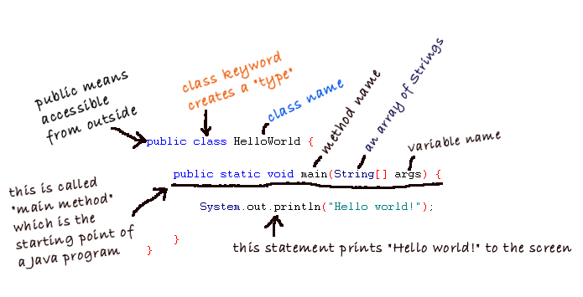

Every Java program starts from the main() method. This program simply prints “Hello world” to screen.

**Compiling it**

In order to compile java program open command prompt and do the following.

Now let’s compile our first program HelloWorld.java file using javac tool. Type the following command to change the current directory to the one where the source file is stored:

**cd C:\Java**

And type the following command:

**javac HelloWorld.java**

That invokes the Java compiler to compile code in the HelloWorld.java file into bytecode. Note that the file name ends with .java extension. You would see the following output:

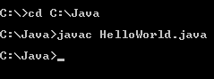

If everything is fine (e.g. no error), the Java compiler quits silently. After compiling, it generates the HelloWorld.class file which is bytecode form of the HelloWorld.java file. Now try to type **dir** in the command line, we’ll see the .class file which is created according to the class name given.

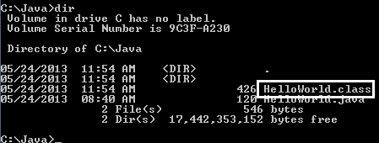

So remember a Java program will be compiled into bytecode form (.class file).

**Running it**

It’s now ready to run our first Java program. Type the following command:

**java HelloWorld**

That invokes the Java Virtual Machine to run the program called HelloWorld (note that there is no .java or .class extension). You would see the following output:

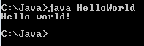

It just prints out “Hello world!” to the screen and quits. Congratulations! You have successfully run your first Java program!